**Get Started with Jetson Nano Developer Kit**

**Introduction:** The NVIDIA® Jetson Nano™ Developer Kit is a small AI computer for makers, learners, and developers. After following along with this brief guide, you’ll be ready to start building practical AI applications, cool AI robots, and more.

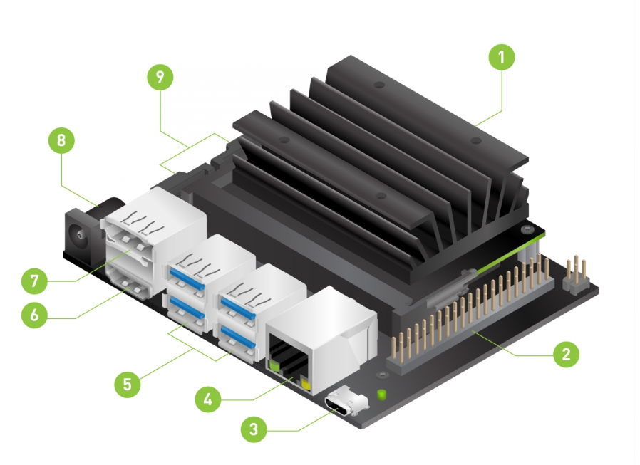

1. microSD card slot for main storage
2. 40-pin expansion header
3. Micro-USB for %V power input, or for Device Mode
4. Gigabit Ethernet Port
5. USB 3.0 port (x4)
6. HDMI output port
7. DisplayPort Connected
8. DC Barrel jack for 5V power input
9. MIPI CSI 2 camera connectors

**Prepare for Setup:**

**Required Items for getting started**

**microSD Card**

The Jetson Nano Developer Kit uses a microSD card as a boot device and for main storage. It’s important to have a card that’s fast and large enough for your projects; the minimum recommended is a 32 GB UHS-1 card.

**Micro-USB Power Supply**

You’ll need to power the developer kit with a good quality power supply that can deliver 5V⎓2A at the developer kit’s Micro-USB port. Not every power supply promising “5V⎓2A” will actually do this.

**Write Image to the microSD Card**

To prepare your microSD card, you’ll need a computer with Internet connection and the ability to read and write SD cards, either via a built-in SD card slot or adapter.

1. Download the Jetson Nano Developer Kit SD Card Image, and note where it was saved on the computer.

The image file approx. (6 GB to 7 GB), after downloading the image file, parallelly download the software name (Balena Etcher).

**After Downloaded the Balena Etcher:**

**Install the Balena Etcher < Connect the SD card in your Device where you install the BE < Select the Image < Select Drive < Flash!**

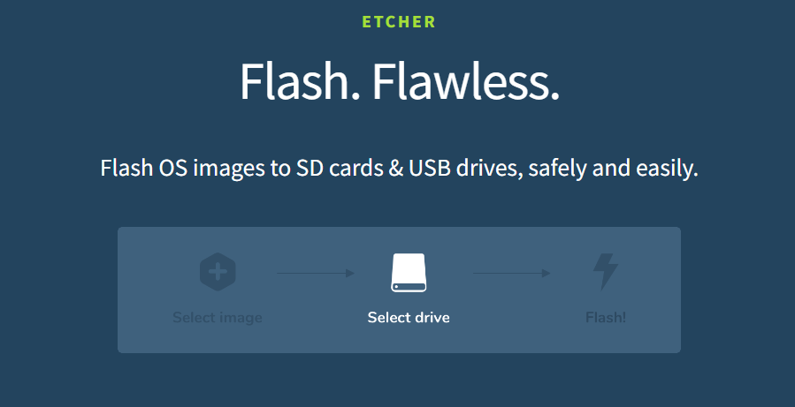

During the Flashing the image in your Device it should be looks like and flashing time (**5 to 15 Minutes**)

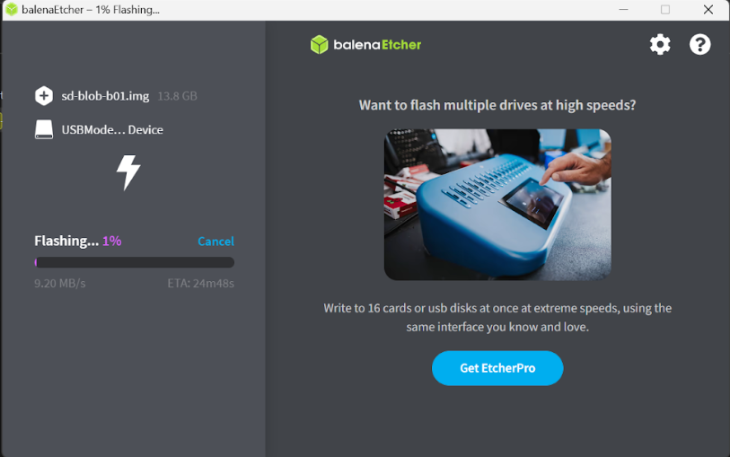

**Main setup of JETSON NANO:**

1. **Fold the paper stand and place inside the developer kit box.**

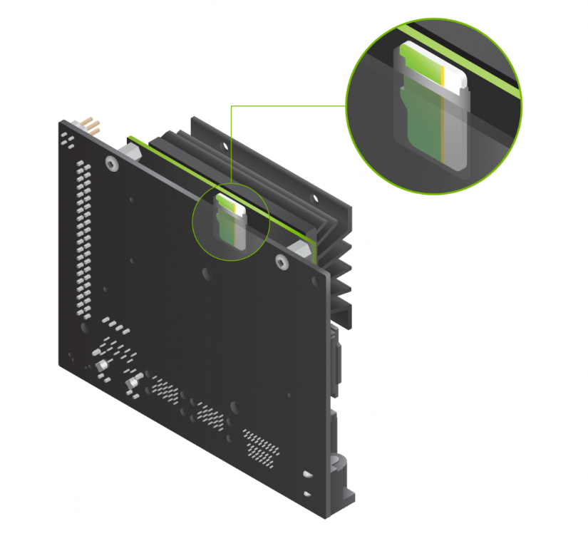

1. **Connect all the peripherals with the NANO:**

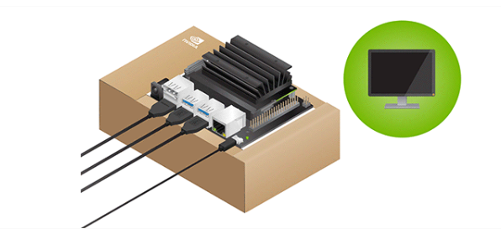

1. **Then power the JETSON NANO with 5V=2A and ready to go.**

**Now let’s Jump to the display of the JETSON NANO:**

1. **First Screen will appear of Terms and Condition**

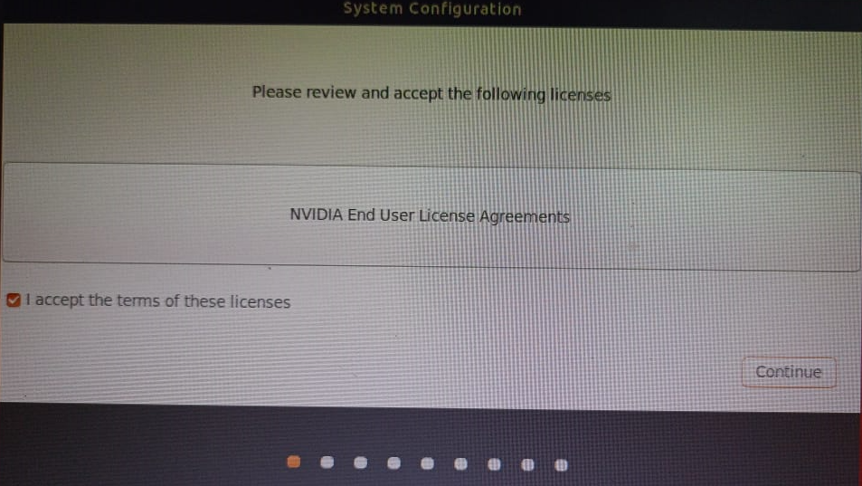

1. **Then select the language**

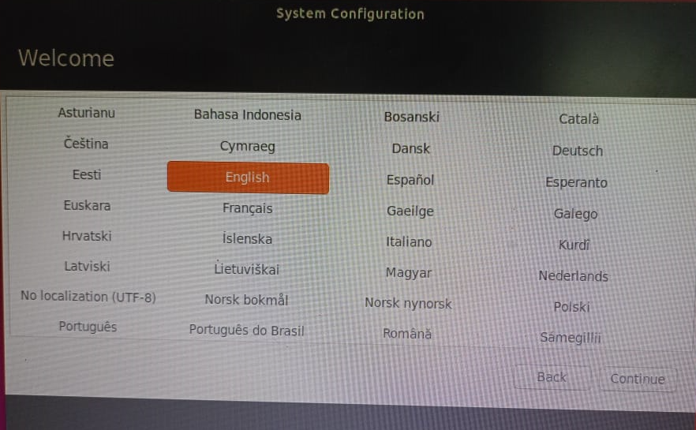

1. **Then keyboard layout**

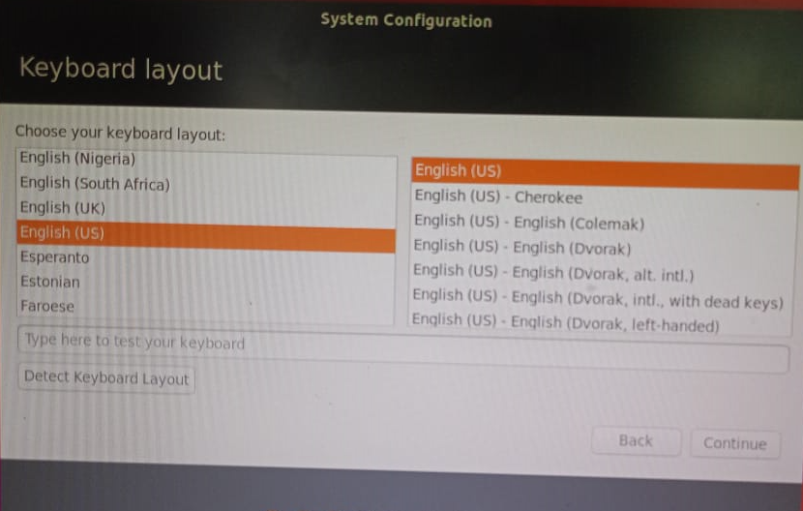

1. **Then set the time zone**

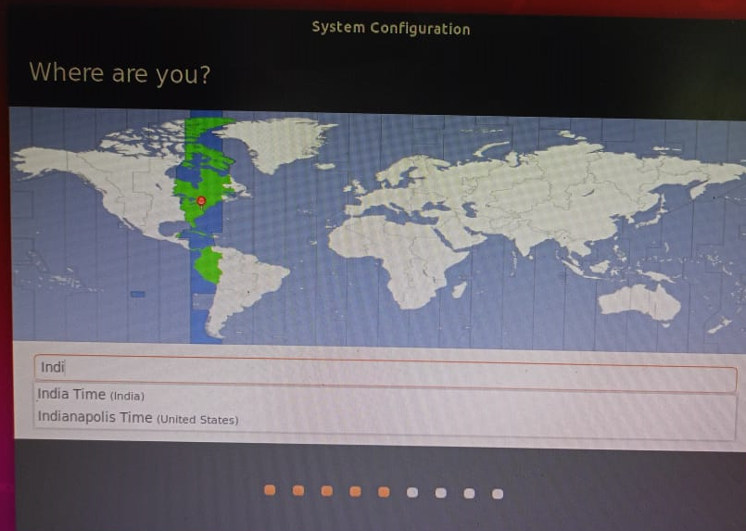

1. **Set up the Name, username and Password**

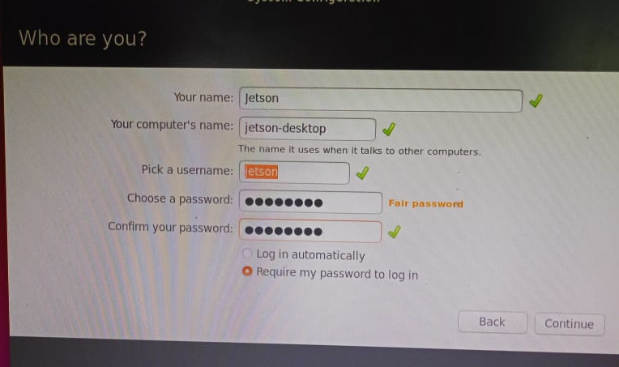

1. **Memory allocation**

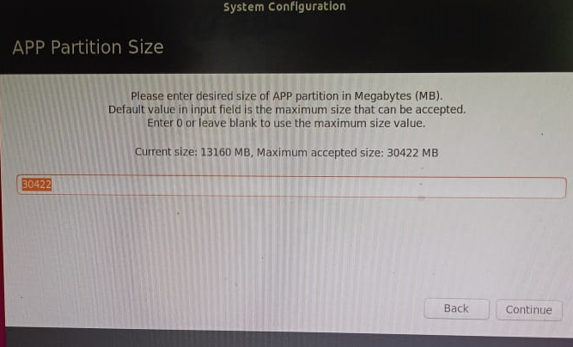

1. **Delete un-used bootloader partition**

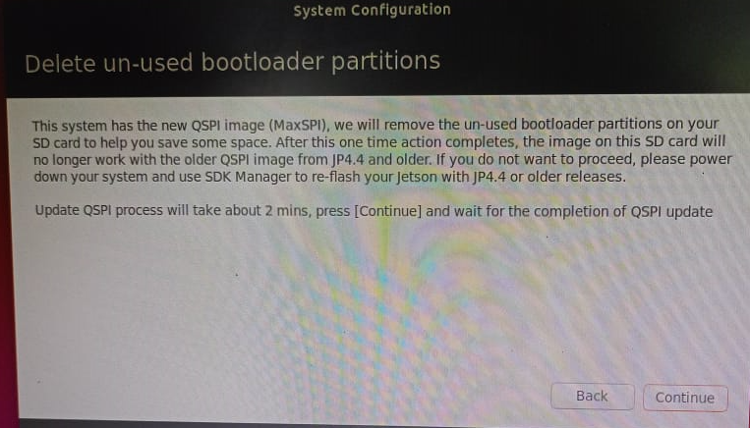

1. **Setup NVP model mode**

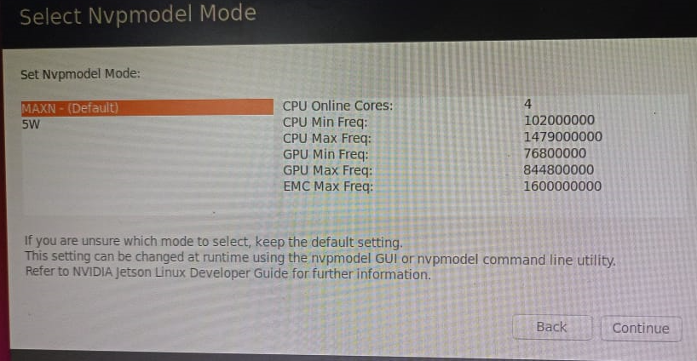

**After these all are stepping the system will initialize their setup and, in few minutes, you will be on your home screen.**

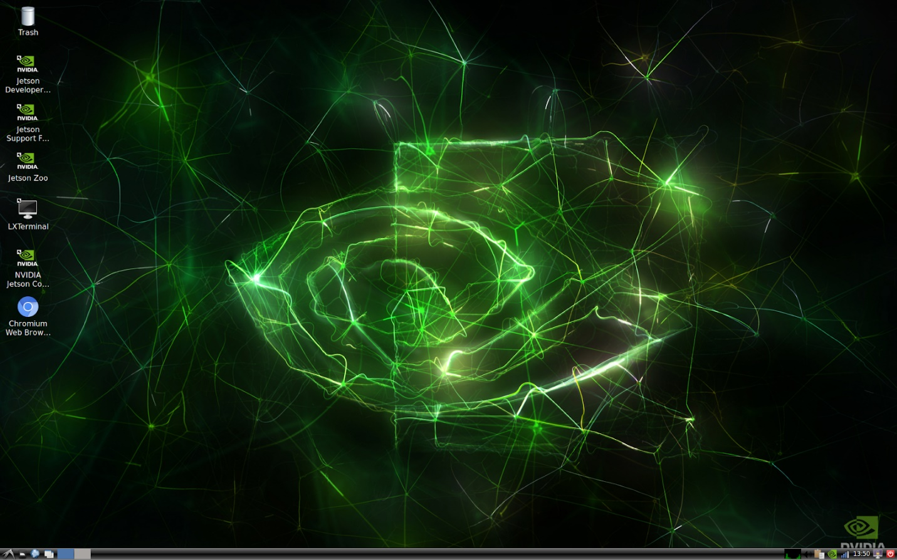

**Conclusion:** In conclusion, setting up the Jetson Nano Developer Kit is a straightforward process that enables you to dive into the exciting world of AI development and experimentation. By following the step-by-step instructions provided, you can quickly get your Jetson Nano up and running, ready to tackle various AI tasks and projects. From initial configuration to software updates and exploring documentation, the journey with the Jetson Nano offers ample opportunities for learning and growth. Whether you're a beginner or an experienced developer, the Jetson Nano Developer Kit provides a powerful platform for innovation and exploration in artificial intelligence and robotics. So, unleash your creativity, start developing, and embark on a rewarding journey of discovery with your Jetson Nano Developer Kit.